## Assignment No # 4

**2023**

## CS 112 Lab Section C

Submitted by: **Syed Muhammad Naqi Raza**

Registration No: **2022574**

Faculty: **Cyber Security**

Class Section: **C**

**“On my honor, as student of Ghulam Ishaq Khan Institute of Engineering Sciences and**

**Technology, I have neither given nor received unauthorized assistance on this academic work.”**

Submitted to:

## Engr Salman Saeed

DATE:

**10/05/2023**

**Task 1:**

**Code:**

**Output:**

**Task 2:**

**Code:**

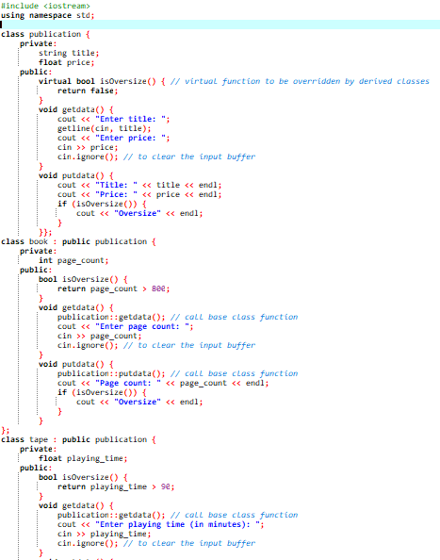

**Output:**

